Creating Identification Cards

This guide refers to creating identification cards for people registered using the household registration form. There is a three step process:

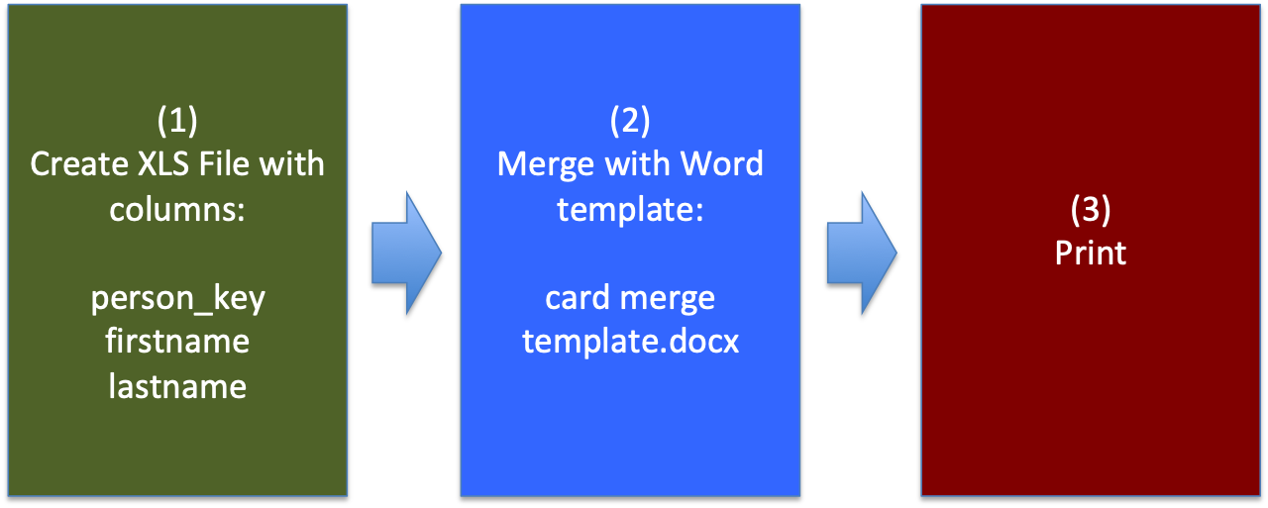

Create XLS File

a) In the Smap server select the menus modules then console. In the console select:
- The project that contains the household registration data
- The household registration survey
- The person form

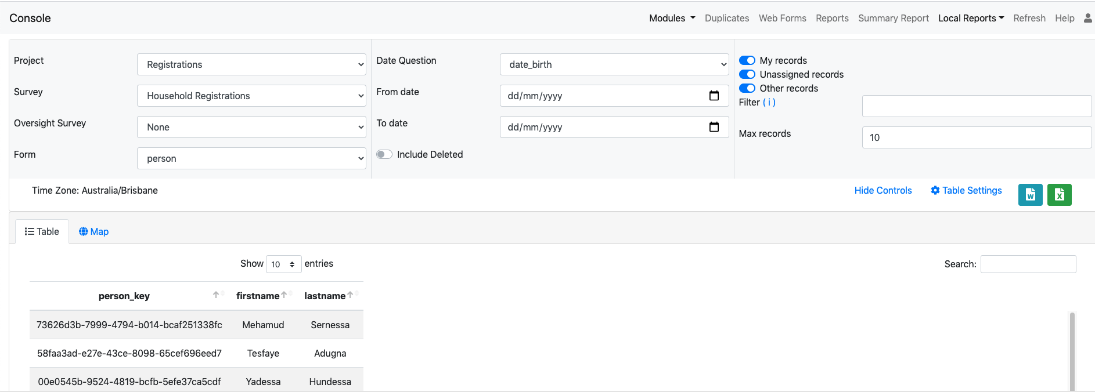

Remember the registration data is collected in a sub form in the person survey.

b) You can filter the data to identify the records you want. Perhaps just selecting the last months registrations.

c) You can then export the selected data to an excel file. However optionally you can select just the person_key, firstname and lastname columns to reduce the file size. You would do this using the “Table Settings” menu just above the data.

Perform the export by selecting the green excel button on the right of the screen just above the data tables.

Merge with the word template

Download the Card Merge Template from the server. It can be found under “Local Reports”
Note The following instructions were created for Microsoft Word version 2010 in Microsoft 365. Older versions of word should still support mail merge but the exact approach may vary.

Open the word template “card merge template.docx” using Microsoft Word.
- A dialog box may be shown “Opening this document will run the following SQL command”. If it is shown then Select No
- Select the Mailings tab
- Select “Select Recipients”
- Select “use an existing list”
- Find the excel file you downloaded in step one and open it
- Select the “Data$” sheet
- Select “Finish and Merge”
- Select “Edit individual Document”
- Select “All”

Do not save this merged document or you will overwrite the template. However if you do you can download the template again from the server.

Print

Print the document. You can then laminate it and cut out the individual cards.

